Please have these ready before coming to the hackfest.

1. Access to an **Azure Subscription**
   * Go to portal.azure.com, login and search for subscriptions on the top search bar. Click the result with the key icon

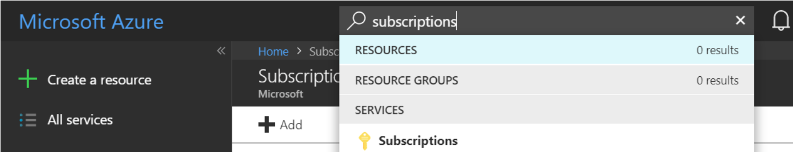

* + On the Subscriptions page make sure you can see a subscription and your role is either **Owner**, **Account Admin** or **Contributor**

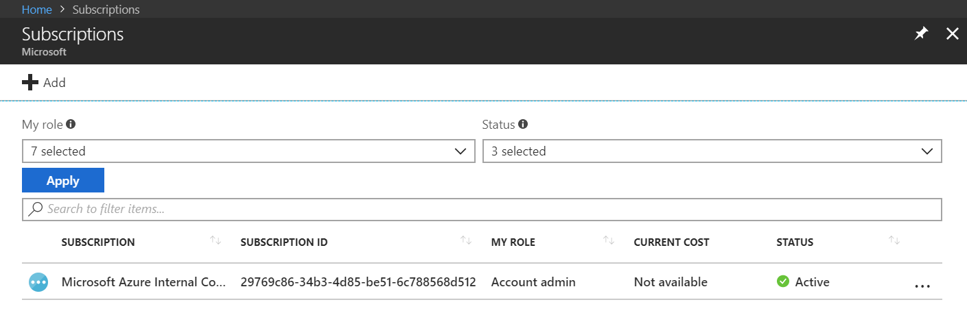

* + If you do not see a subscription, ask the Azure account owner in your company to give you access. If you do not know who your account owner is, please talk to your Microsoft contact.

1. Visual Studio 2017 **installed**on your computer with **Azure Development Workload**.
   * If you don't have Visual Studio 2017, you can download and install the [community edition](https://www.visualstudio.com/downloads/)
   * If you are installing VS2017 for the first time, make sure the below are selected in the select WorkLoads page.
     + Universal Windows Platform Development
     + .NET Desktop Development
     + ASP.NET and web development
     + Azure development

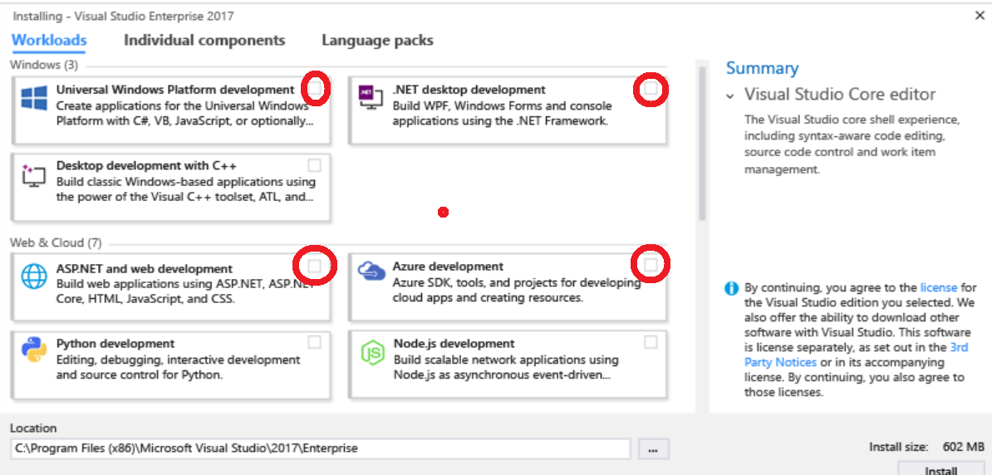

1. Visual Studio 2017 **updated** on your computer
   * After the installation, run VS2017 and go to Tools -> Extensions and Updates. Select updates on the left menu, and install **ALL**updates.

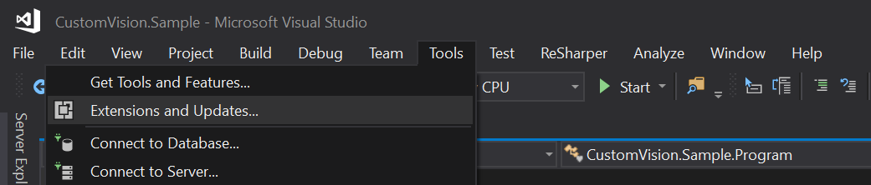

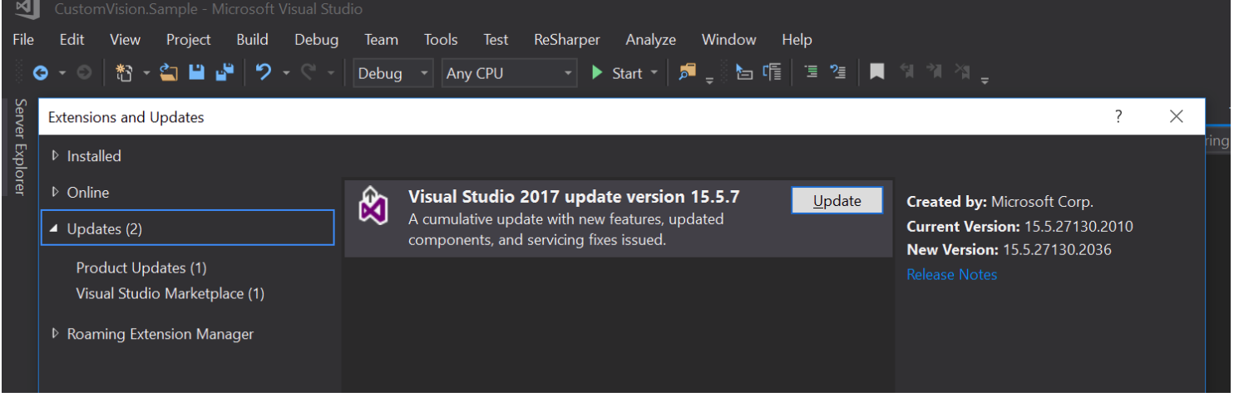

1. Make sure you can connect to the venue WiFi and access the below domains. (Do not have any preventing network policy on your computer)
   * github.com
   * azure.com
   * nuget.org
2. Do not have restrictions which can prevent installing nuget packages to your projects in Visual Studio 2017. To test this, please create a new project and try to add a nuget package to the project. Follow these steps to learn how to add a nuget package: <https://docs.microsoft.com/en-us/nuget/tools/package-manager-ui>